**Associations**

Understanding the associations between Java objects is crucial to working with Hibernate. Representing these associations in Java is quite straightforward: we use a class’s attributes (variables) to do so. You may have already been working with associations without realizing it. Check out the following definition of two simple classes, *Car* and *Engine:*

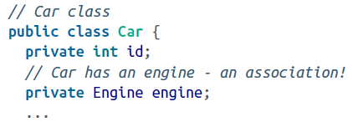

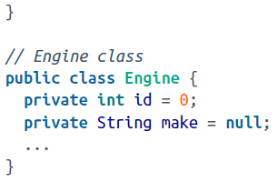

We are defining a *Car* POJO with engine as an attribute. So, this code is indicating that the *Car* class is *associated* with the *Engine* class. In Java, we use the attribute to form associations with objects.

Before we move on, there’s another term that you should understand: *relationships.* Relationships are associations between relational database tables. The relationships between the tables are expressed mostly through primary/foreign keys and other constraints.

When we talk about associations, there are two things that we should keep in mind: ***multiplicity*** and ***directionality***